**8 SCIENCE INVESTIGATION**

OBSERVING HEART RATE

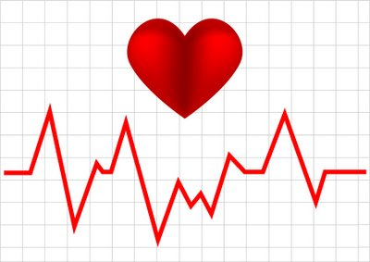

Name:_________________ Teacher:____________

Form:_________________ Due date:___________

**IMPORTANT INFORMATION**

**Plagiarism**

•The experiment is to be done in your science group but your write-up and results are to be done individually.

•Plagiarising = instant zero on assignment and you will have to re-do it.

**Presentation**

•Neat writing (if you struggle with this, type your information).

•Correct spelling, grammar and full sentences.

•Assignment neatly stapled together with this sheet attached to the front.

**Assessment policy**

Have sick note/legitimate reason from parent = new negotiated due date.

Assignment not submitted on due date and no sick note from parents = -20% mark

Assignment not submitted on new negotiated due date = -40% mark

+ Letter home to parents

+ Must attend academic completion to complete assignment

**OR**

Submit assignment to student services before academic completion date and academic completion not necessary.

Academic completion not attended = zero on assignment + Saturday detention

**If you know that you cannot submit your assignment on the due date, let your teacher know BEFORE the due date (email them if you are not in school) or just email them your assignment the night before.**

**Introduction**

Your body systems do not work independently. Each one relies on and affects the other.

Your group will need to design and perform an experiment to work out a way to either increase or decrease breathing rate or heart rate and see what happens to the other. You want to find out how breathing rate and heart rate are related.

Some options you could try are:

* Exercise to increase the heart rate.
* A period of slow, deep breathing.

Hints:

* You will need to repeat the experiment 2-4 times to obtain an average.
* It is very important to control your variables in this experiment and to explain how you did this clearly in your method.

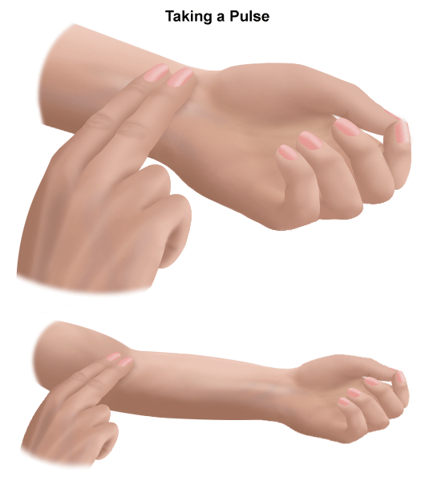

* It is also important to do some research to see if you can find scientific reasons for your results and explain these in your conclusion.

*Pearson Science 9 page: 107 describes how to take a pulse.*

**Title: (1 mark)**

_________________________________________________________________________________

**Aim: (1 mark)**

_________________________________________________________________________________

_________________________________________________________________________________

**Hypothesis:**(prediction with both dependent and independent variables, does not use ‘I’, ‘we’).  **(2 marks)**

_________________________________________________________________________________

_________________________________________________________________________________

_________________________________________________________________________________

**Materials:** (detailed, how many of each item).  **(2 marks)**

___________________________________ _________________________________________

___________________________________ _________________________________________

___________________________________ _________________________________________

**Dependent variable: (1 mark)**

_________________________________________________________________________________

**Independent variable: (1 mark)**

_________________________________________________________________________________

**Two controlled variables: (2 marks)**

_________________________________________________________________________________

_________________________________________________________________________________

**Method** (starting from step one, list the steps that were taken). **(3 marks)**

_________________________________________________________________________________

_________________________________________________________________________________

_________________________________________________________________________________

_________________________________________________________________________________

_________________________________________________________________________________

_________________________________________________________________________________

_________________________________________________________________________________

_________________________________________________________________________________

_________________________________________________________________________________

_________________________________________________________________________________

_________________________________________________________________________________

_________________________________________________________________________________

_________________________________________________________________________________

_________________________________________________________________________________

_________________________________________________________________________________

_________________________________________________________________________________

_________________________________________________________________________________

_________________________________________________________________________________

_________________________________________________________________________________

_________________________________________________________________________________

_________________________________________________________________________________

_________________________________________________________________________________

_________________________________________________________________________________

_________________________________________________________________________________

_________________________________________________________________________________

_________________________________________________________________________________

_________________________________________________________________________________

_________________________________________________________________________________

_________________________________________________________________________________

**Results:**

**Table** (show results taken from experiment, trials and averages, in pencil, with ruler).  **(3 marks)**

**Graph:** show your group’s average results. Draw on graph paper and attach  **(6 marks)**

- Use graph paper.

- Use a sharp pencil and ruler.

- Have a title at the top (independent variable versus dependent variable).

- Work out whether you need to draw a bar graph (different groups of data) or a line graph (showing data changing over time).

- Put the independent variable and dependent variable on the correct axis.

- Label each axis.

- Record the units of measurement in brackets next to each label.

- Use an appropriate scale that has the same pattern the whole way along.

**Discussion** (describe one mistake/error that occurred, explain how it affected the results and how it could be avoided next time).  **(3 marks)**

_________________________________________________________________________________

_________________________________________________________________________________

_________________________________________________________________________________

_________________________________________________________________________________

_________________________________________________________________________________

_________________________________________________________________________________

_________________________________________________________________________________

_________________________________________________________________________________

_________________________________________________________________________________

_________________________________________________________________________________

**Conclusion** (what the results showed, whether the hypothesis was proven or disproven, include figures from results and scientific reasons for the results). **(5 marks)**

_________________________________________________________________________________

_________________________________________________________________________________

_________________________________________________________________________________

_________________________________________________________________________________

_________________________________________________________________________________

_________________________________________________________________________________

_________________________________________________________________________________

_________________________________________________________________________________

_________________________________________________________________________________

_________________________________________________________________________________

_________________________________________________________________________________

_________________________________________________________________________________

_________________________________________________________________________________

_________________________________________________________________________________

_________________________________________________________________________________

_________________________________________________________________________________

**MARKING KEY**

|  |  |  |  |
| --- | --- | --- | --- |
| **Content** | **Description** |  | **Your**  **mark** |
| Title | Descriptive (not ‘Biology Investigation’). | 1 |  |
| Aim | Describes what you are trying to find out (one sentence). | 1 |  |
| Hypothesis | Correctly worded (e.g. if, then statement).  Includes both dependent and independent variable. | 1  1 |  |
| Materials | Listed all materials used.  Is specific – has number of items used. | 1  1 |  |
| Dependent  variable | Lists the dependent variable. | 1 |  |
| Independent  variable | Lists the independent variable. | 1 |  |
| Controlled  variables | Lists two controlled variables. | 2 |  |
| Method | Is written in past tense.  Is written in numbered step-by-step.  Includes all the steps completed in experiment. | 1  1  1 |  |
| Results  table | Drawn neatly in pencil and using a ruler.  Includes the headings and units of measurement.  Includes all the data collected during the experiment. | 1  1  1 |  |
| Results  graph | Shows the average results, includes all the things a graph  requires. | 6 |  |
| Discussion | Describes at least one mistake/error that occurred.  Explains how this mistake/error affected the results.  Explains how this mistake/error could be avoided. | 1  1  1 |  |
| Conclusion | One sentence stating the result of the experiment.  One sentence stating whether hypothesis was proven or disproven.  Uses figures from the results.  Two sentences explaining scientific reasons for the results. | 1  1  1  2 |  |
| Presentation | Correct spelling, grammar, full sentences.  Written neatly or typed up neatly. | 1  1 |  |
| **Total mark** | | 32 |  |

Mark as percentage %

Teacher’s comments:

_________________________________________________________________________

_________________________________________________________________________

_________________________________________________________________________